Farhan Ali Rizwan

Roll no 12  
BSDS-3A  
Artificial intelligence  
  
Program description:

Fizz , buzz game  
Code:

import random

def fizz_buzz(number):

    if number % 3 == 0 and number % 5 == 0:

        return "fizz buzz"

    elif number % 3 == 0:

        return "fizz"

    elif number % 5 == 0:

        return "buzz"

    else:

        return None

def game():

    print("Welcome to the Fizz Buzz Game!")

    range_choice = input("Choose a range: 1 to 10 or 1 to 100? (Enter 10 or 100): ")

    while range_choice not in ['10', '100']:

        range_choice = input("Please enter a valid range (10 or 100): ")

    max_number = 10 if range_choice == '10' else 100

    player1_score = 0

    last_number = 0

    while True:

        player1_number = random.randint(1, max_number)

        print(f"\nPlayer 1 chose the number: {player1_number}")

        fizz_buzz_result = fizz_buzz(player1_number)

        print(f"Fizz Buzz result: {fizz_buzz_result if fizz_buzz_result else 'none'}")

        player2_guess = input("Player 2, is it 'fizz', 'buzz', or 'fizz buzz'? (or press Enter for none): ").strip().lower()

        if fizz_buzz_result is not None and player2_guess == fizz_buzz_result:

            player1_score += 1

            print("Correct! Player 1 gets 1 point.")

        elif fizz_buzz_result is None and player2_guess == "":

            print("Correct! No points given but you guessed correctly.")

        else:

            print("Wrong guess! Game over.")

            break

        if player1_number % 3 != 0 and player1_number % 5 != 0:

            last_number += player1_number

            print(f"Current total (not displayed): {last_number}")

        print(f"Player 1's score: {player1_score}")

    print(f"Game over! Player 1's final score: {player1_score}")

game()

Output:

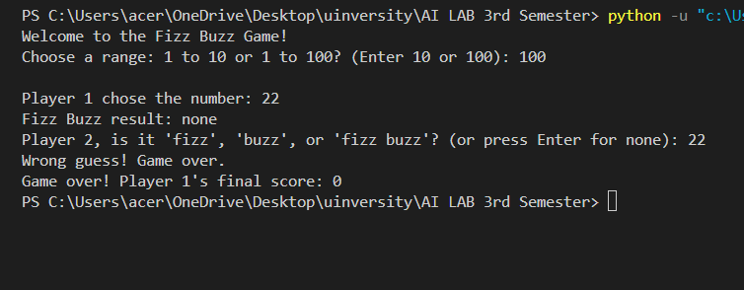  
  
explanation:

The program starts by importing the random library to generate random numbers.

A function fizz_buzz(number) is defined to check if a number is divisible by 3, 5, or both, and returns the appropriate result ("fizz", "buzz", "fizz buzz", or None).

The game () function is created to run the main logic of the game.

The user is asked to choose a range (either 1–10 or 1–100). The program keeps asking until a valid choice is entered.

Variables are initialized: player1_score to keep track of Player 1’s score and last_number to store numbers that are not fizz/buzz.

A loop (while True) runs continuously until a wrong guess ends the game.

A random number is chosen for Player 1 within the selected range and displayed.

The chosen number is checked using the fizz_buzz() function, and the result is shown as "fizz", "buzz", "fizz buzz", or "none".

Player 2 guesses the result by typing it (or pressing Enter if the result is none).

If the guess is correct, Player 1 earns a point. If it’s wrong, the game ends.

If the number was not divisible by 3 or 5, it is added to last_number (tracked but not scored).

After each round, Player 1’s score is displayed.

When the loop breaks, the program prints Player 1’s final score.